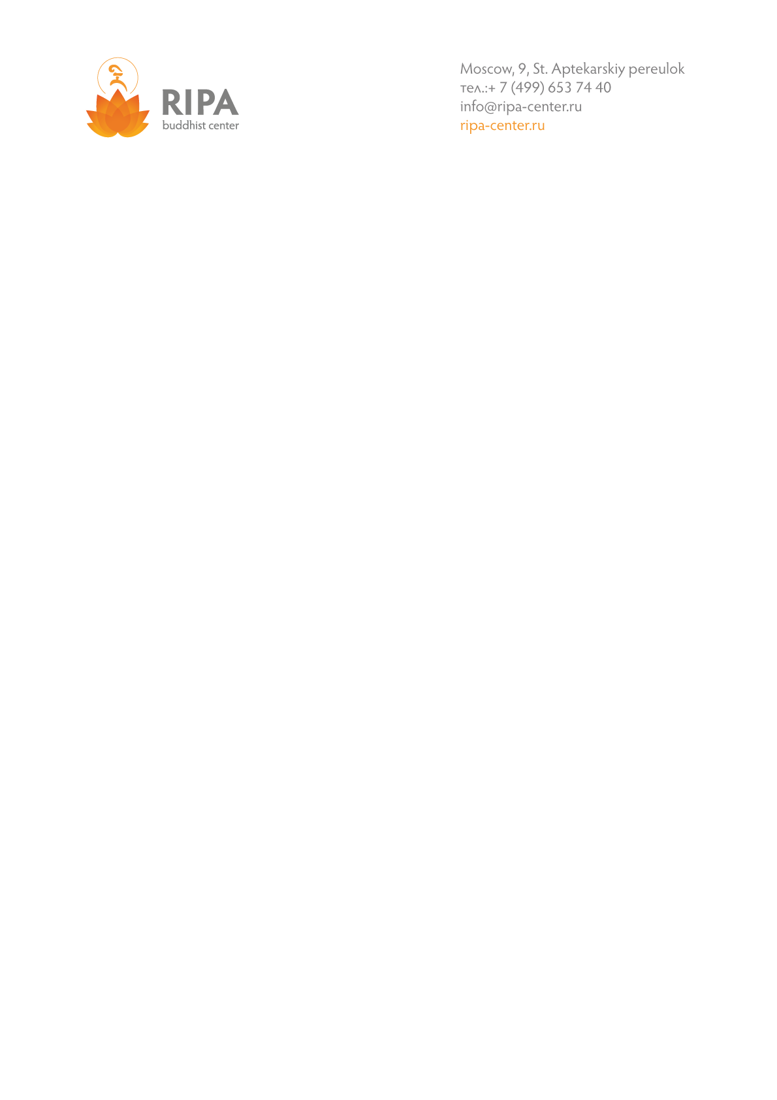

**Dear guests!**

Please, refer to below information about the simplest ways to travel in Moscow, map with location of Ripa Center and how to get it for your convenience.

**From the airports of Moscow:  
1. By taxi**

For example – Commander taxi.   
web: <http://www.komandir.ru/eng/>, Phone: +7 (495) 9 888 888.

Fare is 2500 rub. (≈42 €) from any of airport (Sheremetyevo, Domodedovo, Vnukovo) to area of Metro Baumanskaya. Business class.   
English operator, meeting at arrival zone, payment by credit card are available.

1. **Aero express train from airports to the center**

All the airports of Moscow (Domodedovo, Sheremetyevo, Vnukovo) have connection with city and back way to the airport by comfortable aero express train. Trains go to central railway stations, which are located on the circle line of Metro.  
Domodedovo airport – Paveletskiy railway station (Metro Paveletskaya) - Domodedovo airport  
Sheremetyevo airport – Belorusskiy railway station (Metro Belorusskaya) - Sheremetyevo airport  
Vnukovo airport – Kievskiy railway station (Metro Kievskaya) - Vnukovo airport  
Aero express train fares:

* 450 rub./person (≈7 €)– one way, standard class in tickets offices and vending mashines,
* 1000 rub./person (≈17 €) – one way, business,
* more details about Aeroexpress train in English - http://www.aeroexpress.ru/en

Time of trip – 35/40 min depend on airport. Aeroexpress goes without intermediate stops. English is available in ticket vending machine at the airports, appropriate railway stations and in the web. It is possible to pay by credit card.

Further way:

* By metro to the station you need. Ticket price: 1 trip – 50 rub (≈0,85 €)
* By taxi (see above)

Please, be informed all the announcement in Metro are made only in Russian.

**To get to Ripa Center:**

Location of Ripa Center is nearly metro station Baumanskaya, but this station is closed till the end of 2015 under reconstruction. Due to this public free bus «M» starts from metro station Kurskaya to M.Baumanskaya with two stops: 1. M.Baumanskaya, 2. Aptekarskiy pereulok (final stop). Bus stop is near “Zemlyanoy Val” street, 27. Way time is 5-7 minutes. Please, go by bus till Aptekarkiy pereulok (final stop), go straight 50 meters the same direction as a bus and then turn to the right at the crossroad to the Aptekarkiy pereulok. Further please go straight about 200 meters, you will reach building of Moscow Ripa Center on you right side – Aptekarskiy pereulok, 9.

**Welcome to Moscow Ripa Center!**

*\* all the rates are indicated in euro, according to the exchange rate 59 rub/euro*

