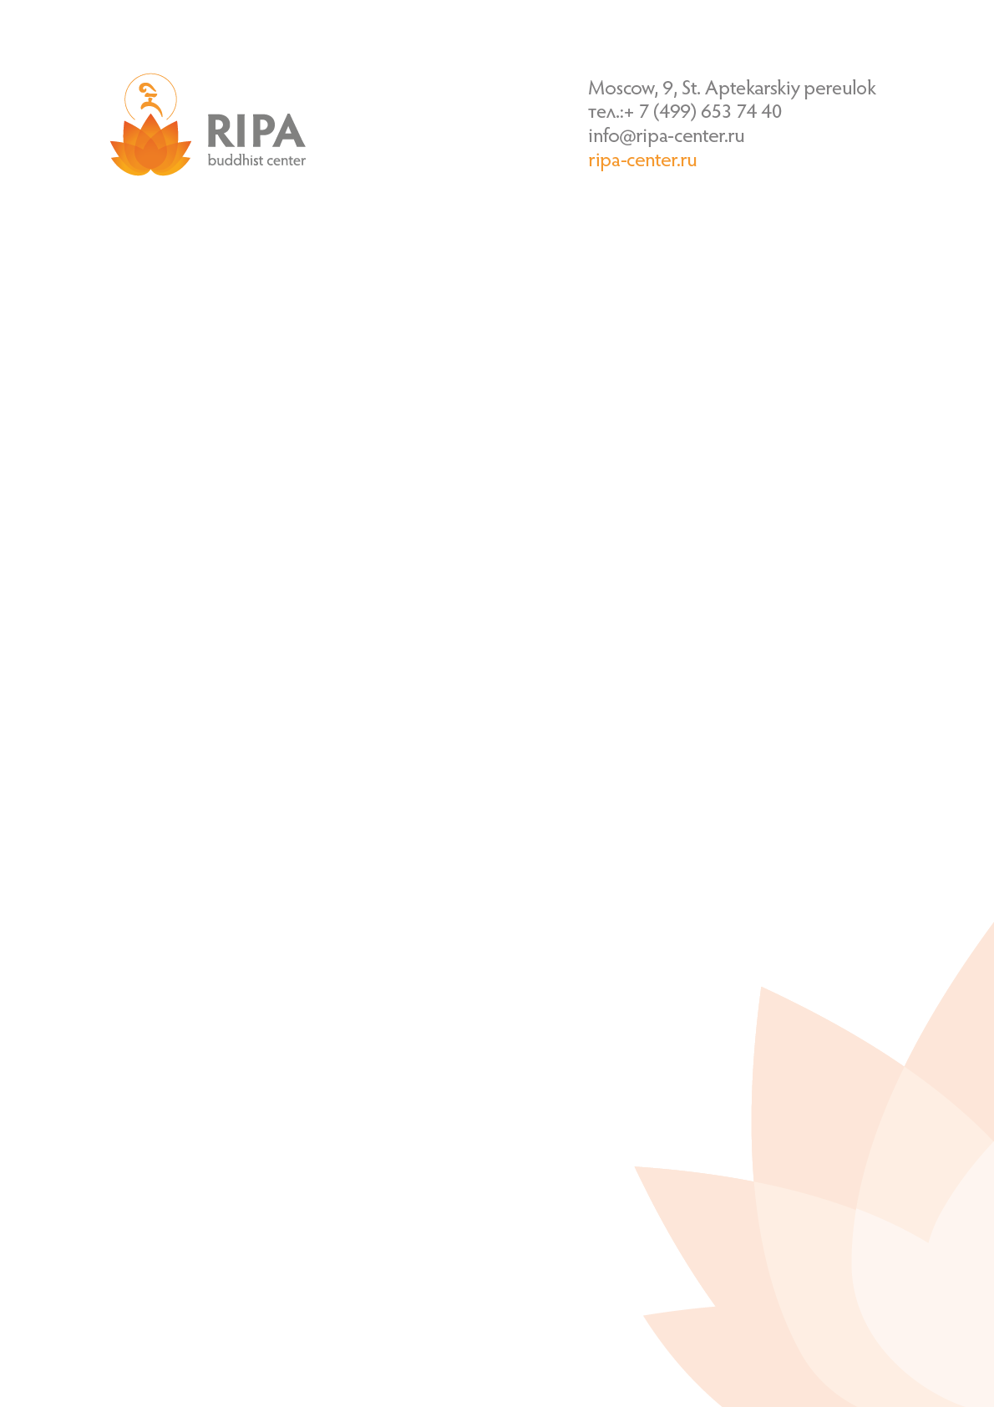

**Dear guests!**

Here you could find list of hotels and hostels of Moscow near Ripa Center:

|  |  |  |  |  |
| --- | --- | --- | --- | --- |
| **Name** | **Distance from Ripa Center** | **Price rate per day, euro** | **Link** | **Address** |
| **Hostels** | | | | |
| Artist Hostel | 550 m | 10-30 | <http://www.artisthostel.ru/en/hostel/baumanskaya/> | Moscow, Baumanskaya street, 35/1 |
| Eurasia Hostel | 260 m | 8-15 | <http://eahostel.ru/eng/> | Moscow, Baumanskaya street, **58 bld.1** |
| Open Hostel Cinema | 1,1 km | 10-30 | <http://open-hostels.com/en/cinema> | Moscow, Novaya Basmannaya street, 18 bld.5 |
| Vesna Hostel | 1,5 km | 10-15 | <http://vesnahostel.ru/en/> | Moscow, Staraya Basmannaya, 5 |
| **Hotels** | | | | |
| Hotel Mercure Moscow Baumanskaya  4* | 250 m | From 60 | <http://www.mercure.com/gb/hotel-8471-mercure-moscow-baumanskaya/room.shtml> | Moscow, Baumanskaya street, 54 |
| Mamaison All-Suites Spa Hotel 5* | 2 km | From 100 | <http://www.mamaison.com/moscow-pokrovka.html> | Moscow, Pokrovka street, 40с2А |

Address of Moscow Ripa Center is – Aptekarskiy pereulok, 9.

In case you need any support in accommodation or visiting Moscow please contact us: forguests@ripa-center.ru.

Warm Regards,

Buddhist Center Ripa